***What is Habitat for Humanity?***

Habitat for Humanity is a faith-based, non-profit organization which builds affordable homes with families who qualify. New homes are sold at cost and financed with no interest. The average monthly payment for a 3-bedroom home can be approximately $300, including insurance and taxes. Families contribute 350 hours of "sweat equity" before moving into their new homes.

***How can I qualify?***

You may be eligible for a Habitat home if you have lived in Nicholas or Webster counties for at least one year and meet our 3 guidelines: need, ability to pay, and willingness to partner.

**1. I have need (check all that apply):**

The housing I now live in is at least one of the following:

___ Overcrowded.

___ Poorly maintained (substandard).

___ In an unsafe neighborhood.

___ I do not have a place of my own.

My income falls within the following guidelines (not including food stamps):

Family Maximum Minimum

Size Annual Income Annual Income

1 $ 20,000 $ 10,000

2 $ 22,800 $ 11,400

3 $ 25,700 $ 12,850

4 $ 28,500 $ 14,250

5 $ 30,800 $ 15,400

6 $ 33,100 $ 16,550

7 $ 35,400 $ 17,700

8 $ 37,700 $ 18,850

**2. I have the ability to pay (all 3 of the following statements must be true):**

___ I have not declared bankruptcy in the past year.

___ I pay my rent, utilities, and other bills on time.

___ I have had stable income for the past year.

**3. I am willing to partner with Habitat:**

**(Both of the following statements must be true.)**

___ I am willing to partner with Habitat and put in

350 hours of "sweat equity" helping to build my own home and further supporting the mission of Habitat in Nicholas and Webster Counties.

___ I will also attend budget and home owners classes.

___________________________________________

If you meet our 3 basic guidelines, please complete the following eligibility screening form.

You can return it to:

Habitat for Humanity

P.O. Box 544

Summersville, WV 26651



**ELIGIBILITY SCREENING FORM**

Name:_____________________________________

Mailing Address:

___________________________________________

___________________________________________

Street Address (if different than mailing address):

___________________________________________

___________________________________________

Phone Numbers:

Home: _____________________________________

Work: _____________________________________

Cell: _____________________________________

Name of Co-Applicant (if another adult lives with you):

___________________________________________

How long have you lived in Nicholas or Webster County? Circle which one.

___________________________________________

How many people will be living in your home, in­cluding yourself?

Adults:___ Children:___

Please list all sources of income — include jobs, Social Security, SSI, disability payments, food stamps, and child support.

|  |  |  |
| --- | --- | --- |
| Source of Income (job, SSI, etc.) | Amount Received Before Taxes | How Often You Receive It (weekly, monthly) |
|  |  |  |
|  |  |  |
|  |  |  |
|  |  |  |

**PLEASE READ THE FOLLOWING:**

**By signing and dating below, I agree that I understand the following:**

**This form is NOT an application for Habitat for Humanity of Nicholas & Webster Counties — the information I have provided will be used to determine my eligibility to submit an application.**

**In order to be considered as a Habitat partner family, I must fill out a complete application through an interview process with a member of the Family Selection Committee.**

**Someone from Habitat for Humanity of Nicholas & Webster Counties will contact me and let me know if I am eligible to apply for consideration as a family partner.**

**_____________________________/_____________**

**Signature Date**

**_____________________________/_____________**

**Co-applicant Signature DateC:\Users\Administrator\AppData\Local\Microsoft\Windows\Temporary Internet Files\Content.IE5\P73K8YP5\MCj03194520000[1].wmf**

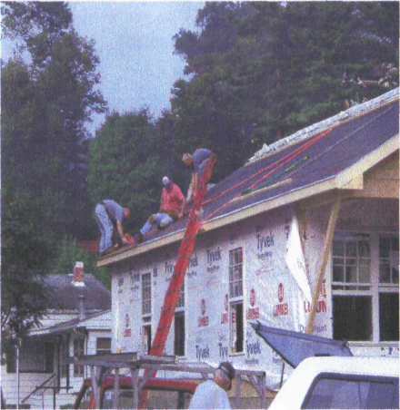

Habitat for Humanity of

Nicholas & Webster Counties

P.O. Box 544

Summersville, WV 26651

304-872-9565

Office location

Robert Lee Office Building

420 Main Street #5 Summersville

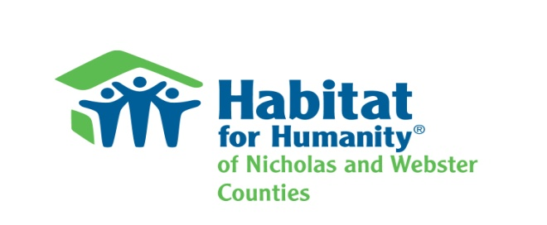How to become a Habitat Homeowner